A Quantitative Analysis of Course Evaluation
What would influence the overall score of a course?
Ethnicity Research Pod | Faith, Leah, Shuo | SOCI 20514
29/11/2020

Introduction
Codebook
Variable Meaning eval #: for future reference sequence: which course? year: which year? instructor: who taught? overall: mean score of the responses to the question “Overall, this was an excellent course.” discussion: … “the instructor facilitated discussions that were engaging and useful.” learning: … “the instructor helped you gain significant learning from the course content.” inclusivity: … “the instructor worked to create an inclusive and welcoming learning environment.” contribution: … “Overall, this instructor made a significant contribution to your learning.”

Descriptive Statistics
We evaluated 205 classes belonged to HUMA or SOSC sequence in the year of 2019. There are 1737 students enrolled in a HUMA course, and 1648 students enrolled in a SOSC course. HUMA courses received a 4.33 overall score on average, while SOSC courses received 4.5. HUMA courses received a 4.58 Inclusivity score on average, SOSC 4.62.

1. Inclusivity Rank
Generally speaking, SOSC sequences perform better than HUMA sequences in terms of Overall score. 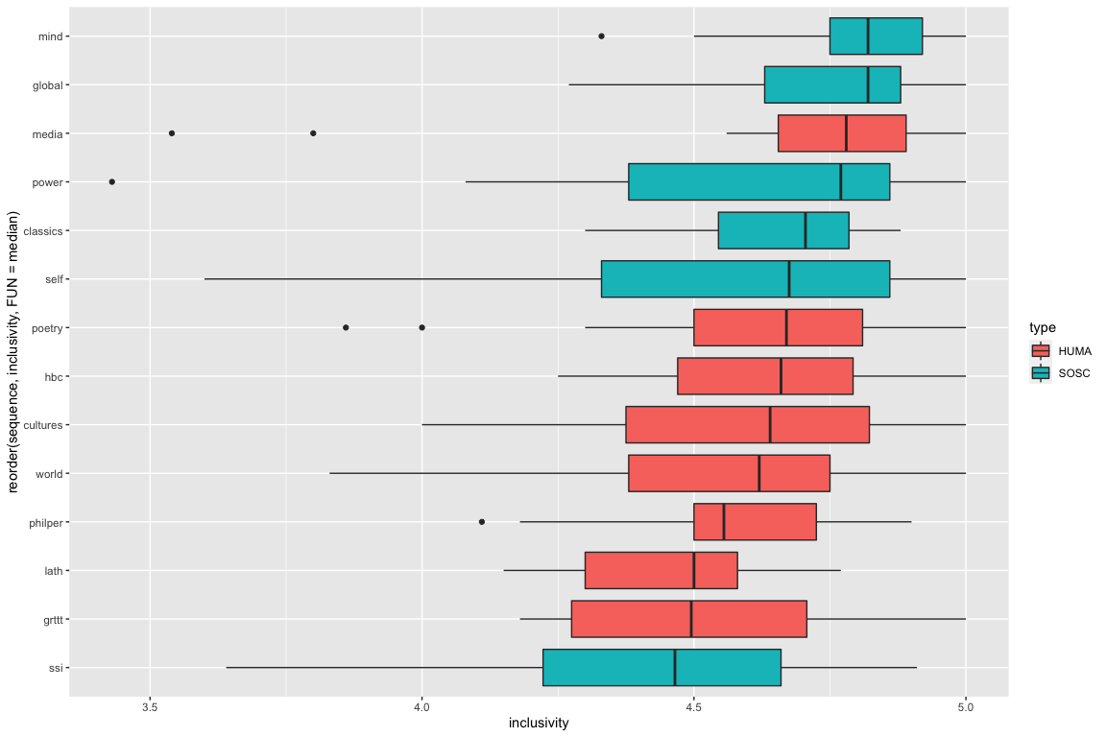

2. Overall Rank
Generally speaking, SOSC sequences also perform better than HUMA sequences in terms of Inclusivity score. 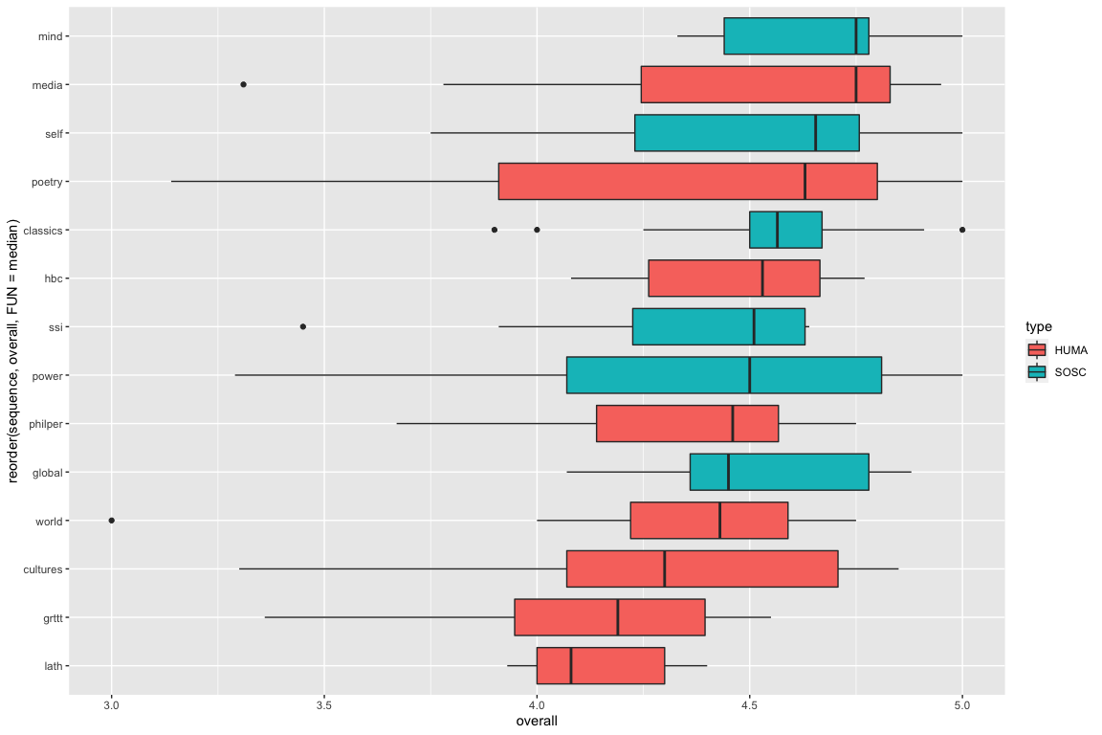

3. Correlation between Inclusivity and Overall
Generally speaking, there is a positive relationship between the two. To achieve a higher overall score, HUMA courses have too have a higher inclusivity score.
Estimate separate linear regression models of the relationship between inclusivity and overall score for each type of course (HUMA/SOSC). The table reports the estimated parameters and standard errors.
## # A tibble: 4 x 8
## # Groups: type [2]
## type data model term estimate std.error statistic p.value
## <chr> <list> <lis> <chr> <dbl> <dbl> <dbl> <dbl>
## 1 HUMA <tibble [104 × 9… <lm> (Intercep… -0.976 0.402 -2.43 1.71e- 2
## 2 HUMA <tibble [104 × 9… <lm> inclusivi… 1.16 0.0877 13.2 8.14e-24
## 3 SOSC <tibble [101 × 9… <lm> (Intercep… 0.434 0.320 1.36 1.78e- 1
## 4 SOSC <tibble [101 × 9… <lm> inclusivi… 0.879 0.0690 12.7 1.42e-22
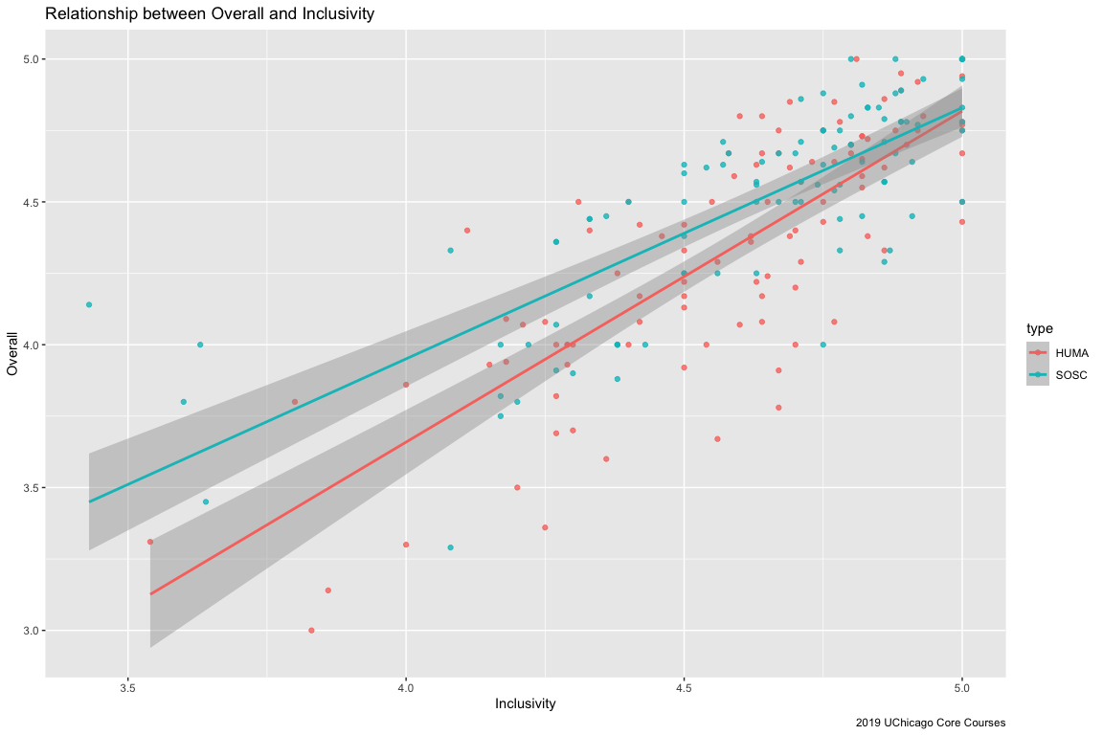

Add more variables into the linear model
Considering HUMA and SOSC together, estimate the linear model: overall ~ inclusivity
term | estimate | std.error | statistic | p.value
(Intercept) | -0.2924976 | 0.2648535 | -1.104375 | 0.2707377
inclusivity | 1.0226578 | 0.0574294 | 17.807225 | 0.0000000
Considering HUMA and SOSC together, estimate the linear model: overall ~ type + enrolled + discussion + learning + inclusivity + contribution
term | estimate | std.error | statistic | p.value
(Intercept) | -0.8525478 | 0.2104793 | -4.0505069 | 0.0000735
typeSOSC | 0.0239532 | 0.0273258 | 0.8765783 | 0.3817834
enrolled | 0.0077900 | 0.0053770 | 1.4487500 | 0.1489973
discussion | 0.1030758 | 0.0615915 | 1.6735394 | 0.0958082
learning | 0.2738445 | 0.0880763 | 3.1091731 | 0.0021540
inclusivity | 0.3160998 | 0.0656531 | 4.8146942 | 0.0000029
contribution | 0.4385587 | 0.0969995 | 4.5212451 | 0.0000106

Graphs
These graphs demonstrate the second linear model: overall ~ type + enrolled + discussion + learning + inclusivity + contribution
It appears that these three variables in the course evaluation are significantly related with the overall score, namely: 1. learning: … “the instructor helped you gain significant learning from the course content.” 2. inclusivity: … “the instructor worked to create an inclusive and welcoming learning environment.” 3. contribution: … “Overall, this instructor made a significant contribution to your learning.” 